Call For Papers
BSA Early Career Event
Saturday 6th April, 2019; University of Aberdeen

Symbolic Objects in Contentious Politics
Objects imbued with symbolic content can be powerful signifiers. In moments of protest and social unrest such objects can divide and unite social groups, tell stories, make declarations, spark controversy, and even trigger violent upheaval. This one-day conference will draw together scholars from a variety of fields to discuss symbolic objects in contentious politics: their meanings, usages, functions, and social responses.

SYMBOLIC OBJECTS are objects which hold symbolic value in contentious political action. We take a broad view of what these include; ranging from flags to protest placards, from controversial statues to symbolic bodies, from Anonymous masks and balaclavas to the machete and the AK47. Importantly, they are not simply symbols (they must be physical objects) nor are they merely objects (they must hold symbolic value). Symbolic objects can symbolise resistance, collective action, and peoplehood (racial, ethnic, religious, political, class, gender, sexuality, and others); they can present narratives, articulate symbolic arguments, and make proclamations; and they can be used as tools in protest and other collective actions.

CONTENTIOUS POLITICS incorporates any form of disruptive action which aims to effect change upon the social order. This includes, but is not limited to, protests, social movements, strikes, resistance, armed insurgencies, guerilla or paramilitary actions, acts of terrorism, and revolutionary coalitions.

In bringing these two phenomena together, we hope to close an existing gap in the literature. The incorporation of symbolic objects into studies of contentious politics remains in its infancy; meanwhile, objects are now making a breakthrough in social theory that it is important to incorporate into our understanding of conflict and political dynamics. Our hope is to interlink these often disconnected areas of research and to expand this important yet under-researched area of scholarship.

All abstracts on the theme of ‘Symbolic Objects in Contentious Politics’ as outlined above will be considered. Abstracts should be no longer than 200 words, and are to be sent to peter.gardner@abdn.ac.uk by Monday 11th March. Accepted papers will be put forward for a special issue of Contention: The Multidisciplinary Journal of Social Protest.

Key Information
- Deadline for Abstracts: March 11th
- Notification of Acceptance: Rolling deadline; within 3 days of submission.
- Date of Conference: 9:30am – 5:00pm, 6th April 2019
- Duncan Rise Library Floor 7, The University of Aberdeen, Scotland.

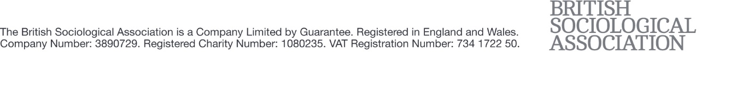
For further details, contact the conference organisers (Peter Gardner, Tiago Carvalho, and Benjamin Abrams) at peter.gardner@abdn.ac.uk.

