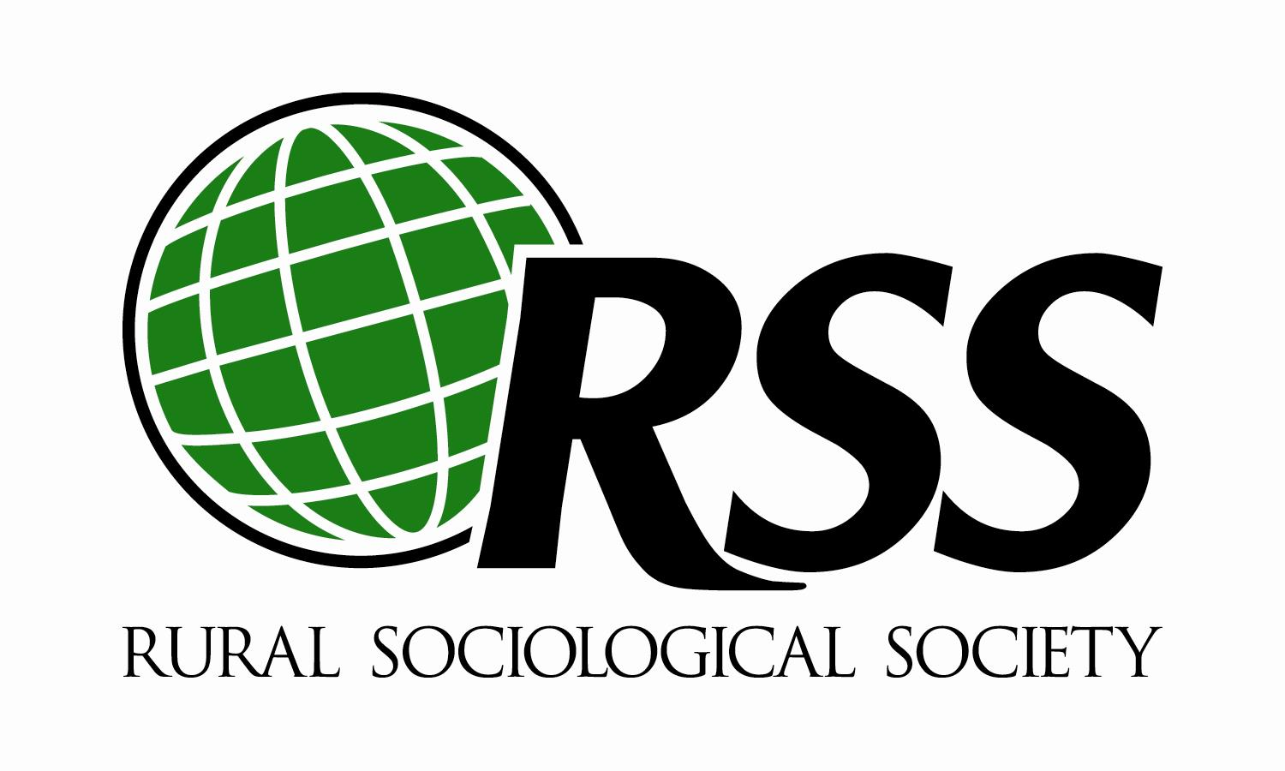

2020 Diversity Travel Award

The Rural Sociological Society (RSS) and the Committee on Diversity are pleased to announce that travel awards are available to support the attendance and participation of minority participants at the annual conference to be held in Westminster, Colorado. These awards will be awarded on a competitive basis and are meant to assist participants in defraying costs associated with attending the RSS meeting.
We anticipate granting awards at the minimum amount of $500 per recipient or at a maximum amount of $750; however, the amount of funds and the number of awards may fluctuate depending on the number of applications and the need described therein.

Eligibility and Application Requirements

To be eligible for the award, an applicant must be:
- An active participant of the meeting by presenting a paper, participating on a panel, or presenting a poster on research. We encourage applications from academics and non-academics.
In addition, for students:
- A student pursuing a degree relevant to rural studies in an academic institution.
- A student member of the Rural Sociological Society at the time of receiving the award.

To apply, an applicant must submit:
- A completed Travel Award Application (see below)

Completed applications should be submitted via e-mail to Ian Carrillo, icarrillo@ucsb.edu not later than Monday, February 17, 2020, 11:59 pm (EST).

The Diversity Committee will make selections and announce decisions by March 31, 2020. No part of the application may be submitted by fax and only applications from individuals on their own behalf will be accepted.

Diversity Travel Award 2020 Application

Name:

First MI Last

Mailing Address:

City | State/province | Zip | Country

Telephone Numbers:
Home: Office/Cell: Email Address:

Do you represent one of the following?

Immigrant ______ African American ______ Asian American ______ Latino/Hispanic _____

Native/ Alaskan Native ______ Other ______

What institution/organization are you representing?

Student Faculty Activist Government Non-Profit _____ Other

Use Word format if more space is needed to answer following:

Please tell us about your interest in the RSS Diversity Travel Award.

Please list the title of your presentation or session at the annual meeting and the nature of your role (e.g., author or coauthor, discussant, workshop leader, panelist, etc.):

How much financial support for attending the annual meeting can you expect to receive from your institution?

Please state any financial hardships that you may have that would preclude you from participating at the annual meeting.

Finally, please state what potential benefits you will garner from participating in the meetings.

